4L Encore Schedule
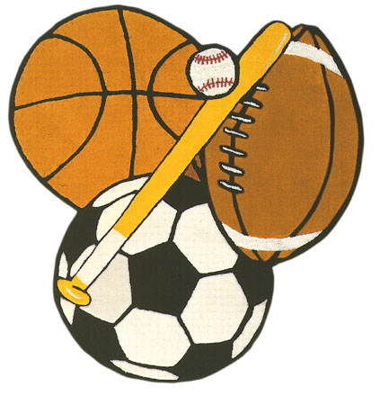
Day 1 – Gym
Day 2A – Guidance
Day 2B - Library
Day 3 - Music
Day 4 – Gym
Day 5 – Art
Day 6 – Music
Day 7 – Gym
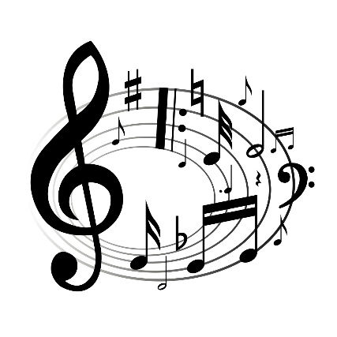
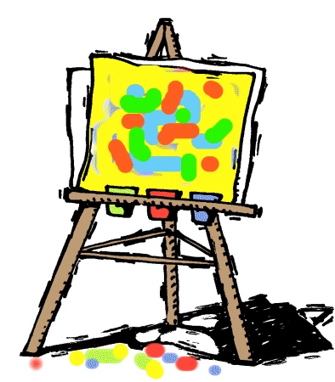
Day 8 – Library
Day 9 – Art
Day 10 – Gym
Day 11 – Music
Day 12 – Art

